**Report DBMS**

**Team Details**

1. Meet Sheladiya - 19BIT076
2. Renish Jagani – 19BIT108
3. Rishit Samariya – 19BIT109
4. Rishabh Patel – 19BIT141
5. Ujash Thakkar – 19BIT142
6. Ananya Khandelwal - 19BIT144

**WORK DONE TILL 28/02/2021**

1. File system vs. DBMS (Experiment - 2)

2. 24 Tables of Stadium Seat Booking Management system. (Experiment - 2)

3. Relational model of Stadium Seat Booking Management system. (Experiment – 2)

4. ER model of Stadium Seat Booking Management system. (Experiment – 3)

5. Installation of MySQL Software Relational Database Management System. (Experiment – 5.1)

6. Relational Algebra queries for the ABC. Clearly write the definition as well as

Relational algebra queries for each. (Experiment – 4)

1. Introduction to SQL, DDL, DML, DCL, database and table creation, alteration,

Defining Constraints, primary key, foreign key, and unique, not null, check, IN operator. (Experiment – 5.2)

1. Study and use of inbuilt SQL functions - aggregate functions, Built-in functions Numeric, date, string

Functions. (Experiment – 5.3)

1. Study, write and use the set operations, sub-queries, correlated sub-queries in SQL Study and use of group by, having, order by features of SQL. (Experiment – 5.4)
2. Study and use of group by, having, order by features of SQL. (Experiment – 5.5)
3. Study different types of join operations, Exist, Any, All and relevant features of SQL.

(Experiment – 5.6)

1. Study and implement the assignment topic from the Embedded SQL, PL SQL Concepts, Cursors, Stored Procedures, Stored Function, Triggers, Tuple relational calculus, domain relational calculus. (Experiment – 5.7)

**Assignment – 2**

In Assignment-1 we have stated the limitations of the file system in comparison to DBMS by pointing out the differences in the aspects based on **Data Inconsistency, Data Redundancy, Atomicity Problem, Data Security, Data Integrity and Data Isolation**. Each member described the topic assigned to them and gave one example related to the project of each topic.

1. **Data Inconsistency**

|  |  |
| --- | --- |
| **FILE SYSTEM** | **DBMS** |
| **Description-**  Data Inconsistency in file system means that different files may contain different details of a particular object or person. The retrenchment actually leads to inconsistencies. When the same data is stored in multiple locations, flexibility is possible. | **Description: -**  An Inconsistency in database occurs when the configuration file is marked as such after Ingres encountered a problem while processing the database. This leaves the database inaccessible and unusable until the problem is resolved. Data  Inconsistency is a situation where many tables within data deal with the same data but can find it in different inputs. |
| **Example 1 -** Data Inconsistency occurs in file system when Booking a Seat for stadium if any spectators has record of 2 different phone number then system for that data will be unable to identify seat number which is allocated for that spectator, while DBMS would not allow to book the seat. | |
| **Example 2 -** If a person has book seat for two consecutive scheduled matches and have entered the same data for both matches if any one of the match gets cancelled then file system might not give correct message to that person but in DBMS has separate relation between two matches. | |
| **Example 3 -** Data Inconsistency can impel if a spectator orders meal for two different timings while booking seat with same data then file system would not respond because file system could not identify that which order is cancelled but DBMS database has unique relation with different input tables. | |
| **Example 4 -** If a person has initially booked a seat for match and entered data like name, phone number and later book the another seat and entered the same data as previous data then in file system it will show error because if any updating happens system would not recognise that in which ticket updating had happened but in DBMS an foreign key is created where the table of one input is related to the other table. | |
| **Example 5 -** While booking seat If any spectator has his home address at two different data storage location it will occur an error in DBMS because if that spectator moved to some other city and then change the address in one of the location but the other location has previous same address so it will lead from data inconsistency to data redundancy. | |
| **Example 6 -** Data Inconsistency constrains can happens if audience from the different location but same street address name books seat file system could not process the further but in DBMS attribute with same value have unique relations and they are bound with different input tables. | |

1. **Data Redundancy**

|  |  |
| --- | --- |
| **FILE SYSTEM** | **DBMS** |
| **Description: –**  In file system, same piece of data can occur in multiple tables through various inputs and this situation is known as data redundancy which is highest in File System. | **Description: –**  In DBMS Data redundancy is lowest, the data is not repeated more than once. |
| **Example 1** – A redundancy situation can occur in file system where two persons  Booked the same seat for the same match, while DBMS won’t allow the booking of same seat again by the later person. | |
| **Example 2** - Two persons with same name and surname applied for booking the VIP seats, in File system it will create redundancy but in DBMS it will bifurcate the two with unique booking ID. | |
| **Example 3** - File system will create redundancy when more than one person having the same street address will book the tickets, but DBMS will reduce the redundancy by separating streets in one table and then just reference the correct Foreign key to the street table. | |
| **Example 4** – If more than one person choses to order for the same meal during the match interval, the file system will create redundancy and it will ultimately lead to data corruption i.e., the food staff will not be able to distinguish the orders of the audience, on the other hand DBMS will reduce the redundancy by making separate table for meal and connect the foreign key to the table. | |
| **Example 5** – Data redundancy is bound to take place in file system when all those who opted for a jersey of the same team to wear at the match to cheer up the players and it will lead to decrease in efficiency of work flow of distributing the jerseys while this will not be the case in  DBMS. | |
| **Example 6** – The size of the database will be unnecessarily increased in the File System when the data of the audience from same city will be stored, while DBMS will segregate the data by making different tables and interconnecting with the help of keys. | |

1. **Atomicity Problems**

|  |  |
| --- | --- |
| **FILE SYSTEM** | **DBMS** |
| **Description: –**  Atomicity is the guarantee that a series of operations either succeed or fail together or refers to “All or nothing”. Which means either all the operations in a transaction executes or none. | **Description: –**  Databases often have features that allow a series of operations to be committed at once as a single transaction there is only succeed in this. |
| **Example 1** – An Atomicity situation can occur in file system where during the buying of ticket if we buy stadium ticket and amount has deducted from account and from bank’s summary account and amount will credited to the seller. If this all not happen as an atomic transaction and there is failure during transaction and there system are not showing the amount either it is receive or not, then we will not able to stadium ticket and the amount of ticket will be also reduced. Whether in DBMS case the transaction will be place easily and if failure occur then also there system will show the amount. | |
| **Example 2**- If we prebook the seat with some beverages and snacks it will store in ticket counter file system and it will see by food counter for snacks and beverages for which seats but if the seats are booked and there is failure in system during sharing of data, due to which it will be unable to know food counter which food to whom. It is atomicity issue in file system but in DBMS it will be easily access the data after failure to. | |
| **Example 3** – If the same person book ticket for X, Y, Z for one executive seats and for others VIP lounge the data was store by the ticket counters file system and the ticket are given to person but during the match there is failure in system during sharing of data and there is no data for VIP lounge persons they will be not allowed to seat if there data don’t show it is atomicity problem but in the DBMS during the failure the data will not vanish at all. | |
| **Example 4 –** File system will create atomicity problem during the home delivery of tickets if we book the tickets by phone call and the money has been credited in there account they deliver the ticket by post but there is failure in the system during the ticket seller and post office the data will be not seen by post office because of the failure in file system and ticket will be unable to receive at home but in the DBMS the data will be not erase during the failure and it will easily access by the post office. | |
| **Example 5-** The atomicity problem also occur, during the file system while buying the food during the match with table service the money was paid for table service food but during the failure in system data was lost and money was paid for food with table service but it only show for food not table service but in the DBMS the data will be stored in the server and during failure also it will not erase. | |
| **Example 6-** While the buying the supporting team costume it will lead to atomicity problem in file system. The amount of costume was paid Rs.1000, and amount was deducted from the buyer account and it will show to the costume counter but during the transaction of money there is the failure in there system it will lead big deal in file system and after the failure the system will not show the payment is done or not or the money has credited in there account or not but the money will be deducted from buyers account. The counter will not give the receipt too. But in DBMS the data will be stored in server and it will be easily access after the failure from the server. And they will show the amount credited and we will get receipt. | |

1. **Data Security**

|  |  |
| --- | --- |
| **FILE SYSTEM** | **DBMS** |
| **Description** - File systems provide less security than DBMS and also possess the less security enchasing elements as compared to DBMS. | **Description** - DBMS has more security mechanisms as compared to file system. It contains range of security controls designed to protect the Database of system. |
| **Example- 1** To access the database of customers purchasing tickets online we can use security measure in DBMS that include verification while accessing data and allows only authenticated users to access the sensitive database. | |
| **Example-2** DBMS provides with features such as access control unlike of File System that includes security mechanisms in a database management system to grant protection against unauthorized access. | |
| **Example-3** Sensitive database of customers trying to purchase the Stadium ticket online can be protected using DBMS. | |
| **Example-4** Datasets such as Seat Number, Payments, and Personal records can be easily backed up and recovered in DBMS in case of data loss. | |
| **Example-5** Unauthorized access of customer’s database by hackers is more prominent in the case of File System than DBMS. | |
| **Example-6** Techniques such as encryption can be used in DBMS to protect sensitive information of ticket buyers. | |

1. **Data Integrity**

|  |  |
| --- | --- |
| **FILE SYSTEM** | **DBMS** |
| **Description: -**  There will be times where it is essential to add certain constraints to the data before entering it into the database. No procedure is provided by the file system to verify these constraints automatically. | **Description: -**  Whereas by imposing user-defined data constraints on its own, DBMS preserves data integrity. |
| **Example 1** — While booking a stadium seat, a user could mistakenly attempt to enter a date field with a phone number. It would prevent the user from making these errors if the device enforces data integrity. | |
| **Example 2** — A person attempts to input a phone number in an incorrect format while entering his personal details for booking a stadium seat. | |
| **Example 3** — In the application of stadium seat booking system, an error tries to erase wrong records. | |
| **Example 4** — While booking a seat, a user might enter wrong details and attempts to erase a record from a table, but as part of a connection, another table cites the record. | |
| **Example 5** — When there is already a foreign key in a similar table pointing to that number, a user attempts to change the primary key value. | |
| **Example 6** — While entering the date of the match, user attempts beyond an appropriate range to enter a date. | |

1. **Data Isolation**

|  |  |
| --- | --- |
| **FILE SYSTEM** | **DBMS** |
| **Description: -**  It is often difficult to find information stored in different files in different departments. Sharing information from multiple, separate files is a complex process and usually requires computer programming knowledge. | **Description: -**  The word ‘Isolation’ means separation. In DBMS, Separation is a data domain where no data should affect another and can appear simultaneously. In short, working on one database should start when working on the first database ends. |
| **Example 1** - Data Isolation occurs when a person is booking a seat uses payment system, they actually create a sub-account with the same permissions as everyone else, but they exist differently across the entire network. | |
| **Example 2** - While booking a seat when a person's financial Transaction 2 changes the row, but does not make any changes. Activity 1 and read the unintended details. Now if Transaction 2 reverses its changes already read by Transaction 1 or updates different changes to the database, viewing the data may be incorrect in Transaction 1 records. | |
| **Example 3** - If a person1 while booking seats issues a transaction against at the same time that person2 issues a different transaction, both transactions should operate independently. Database should either perform person1′s entire transaction before executing person2’s or vice-versa. This prevents person1’s transaction from reading intermediate data produced as a side effect of part of person2’s transaction that will not eventually be committed to the database. | |
| **Example 4** - Data Isolation in this situation occurs if a person buys ticket and books seat and another person trying to book the same seat then the one whose transaction completes first the seat allocate to that person because in DBMS both activities are happening separately. | |
| **Example 5** – while booking a seat if person wants to books VIP seats but in file system doesn’t specify that which one is VIP and which one is Executive lodge and file system books the Executive lodge but in  DBMS specification between two distinct label seat are mentioned. | |
| **Example 6** – A person wants to books a specific team material but when that person receive other team material then data isolation occurs in file system but in DBMS data of one table would not affect the data of other table. | |

**Assignment - 2**

In Assignment-2 the assigned topic is relational model and it is group assignment so we have divided 4 tables for every member in our team and we have created Relational model in **lucid chart** and each member has given different entities and their attributes. In that we have created **primary key** and **foreign keys** and made relation between them In Relational model for Stadium Seat Booking management system we have shown relations and underlined primary key and made **relation** between them and we have finally done our group assignment - 2 on 21st Feb.

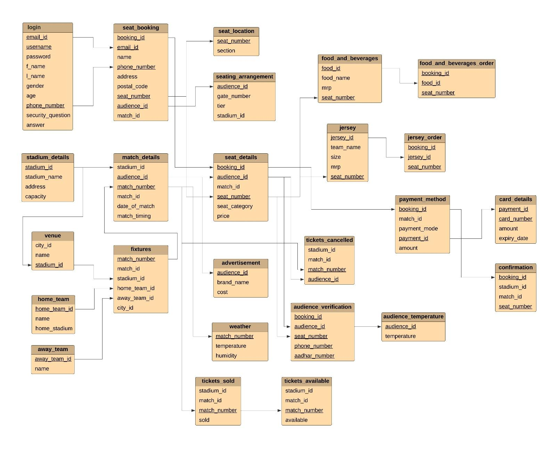

**Assignment – 3**

In Assignment-3 we have formed **Entity Relational Model** by establishing the relations **(One-to-One, One-to-Many, Many-to-One, Many-to-Many)** between different entities. Each entity in entity set is containing at least one relationship in relationship set. The **Primary key** and **foreign key** are underlined in the diagram itself. This model was formed in lucid chart and everyone contributed in it.

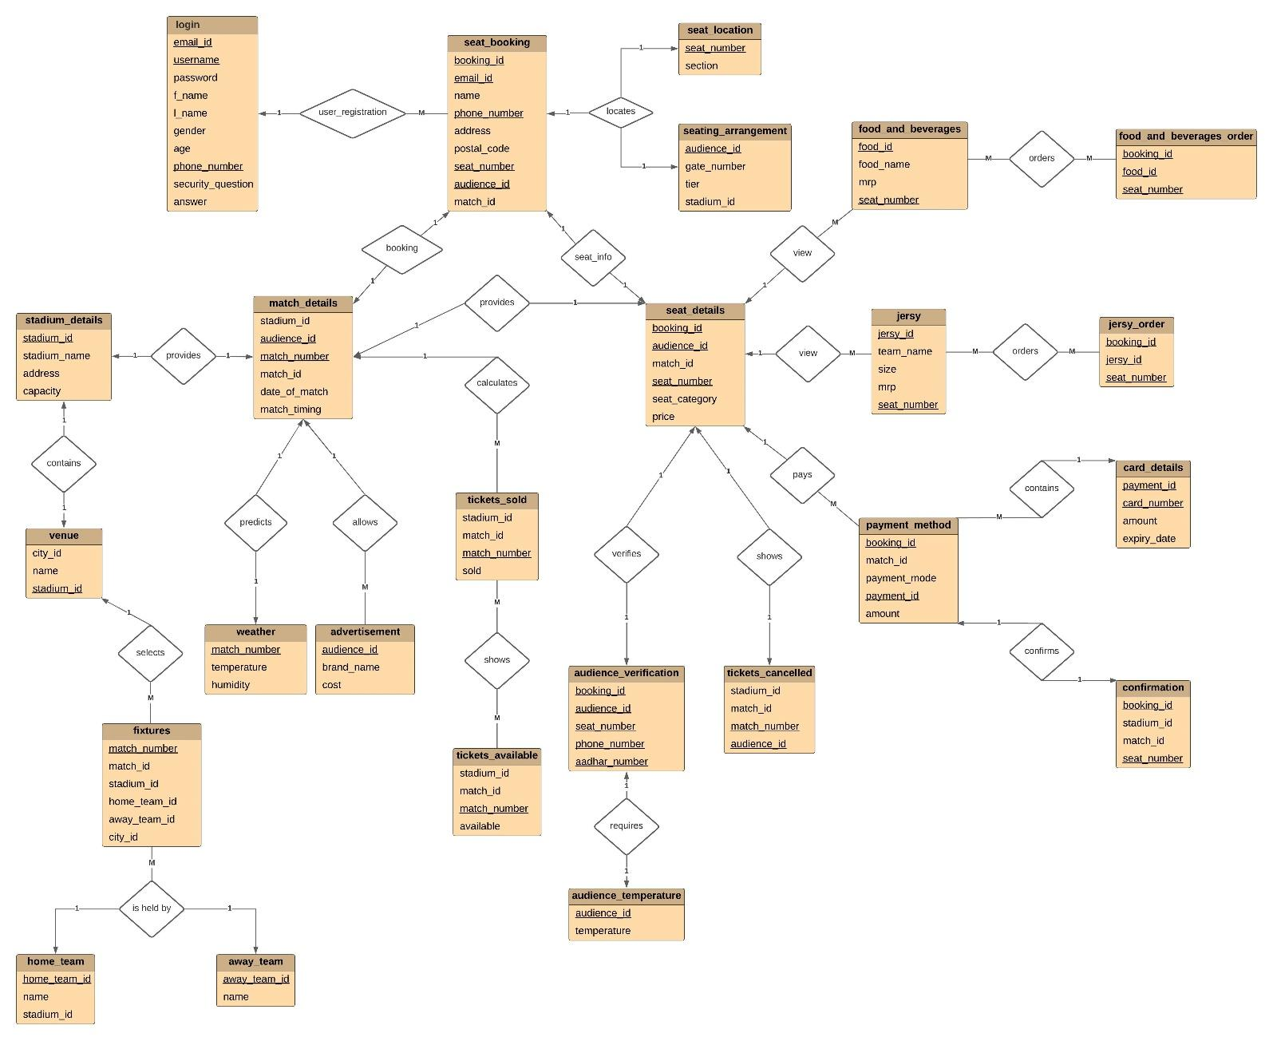

**Assignment – 5.1**

**Topic:- Installation of MySQL Relational Database Management System**

**Objective:-** To learn basics of MySQL software that can be used for SQL Query evaluations.



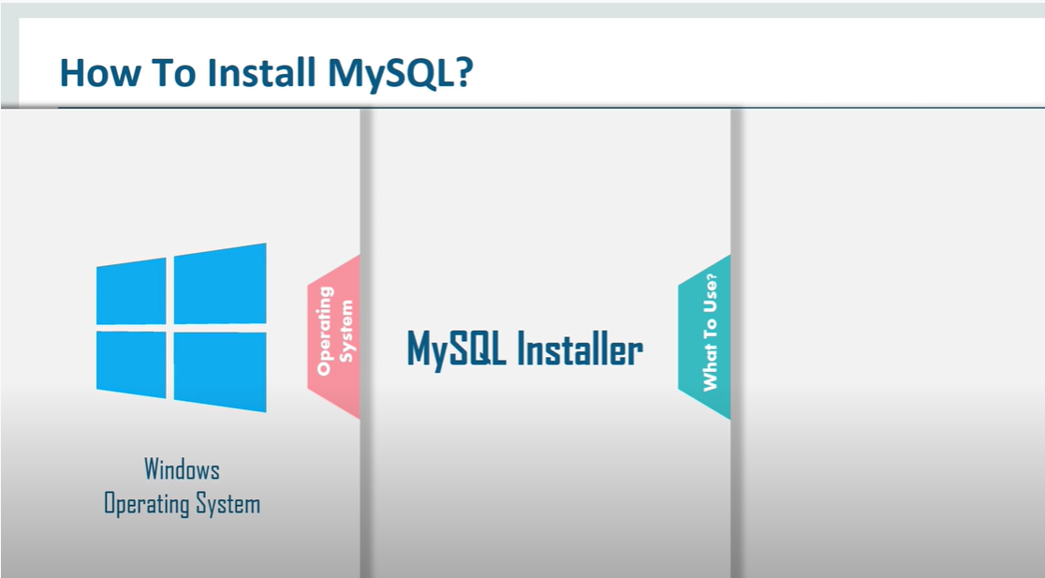

**Follow the Steps Below:-**

**STEP: - 1**

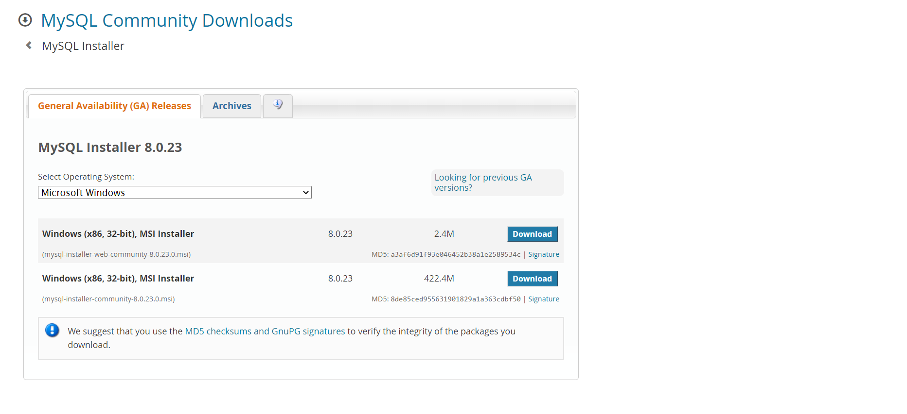

**STEP: - 2**

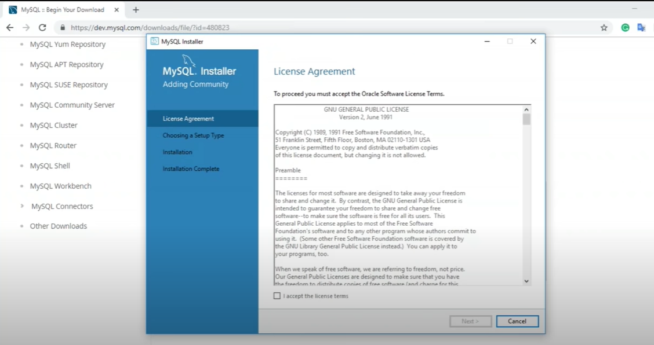

**STEP: - 3**

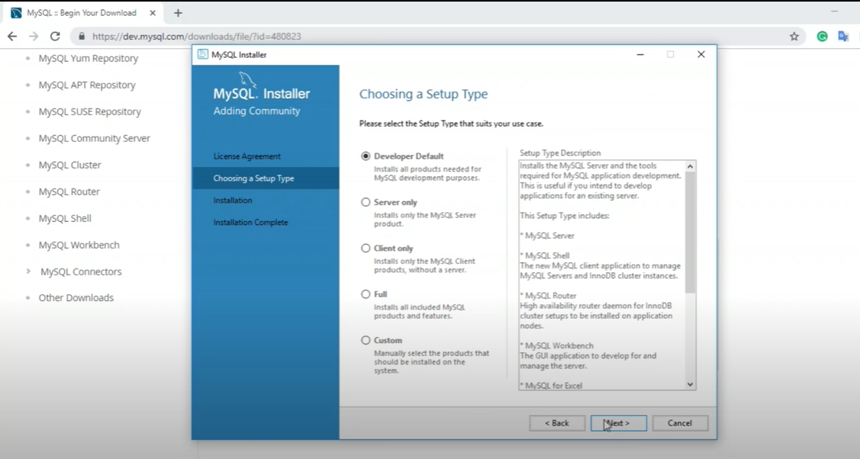

**STEP: - 4**

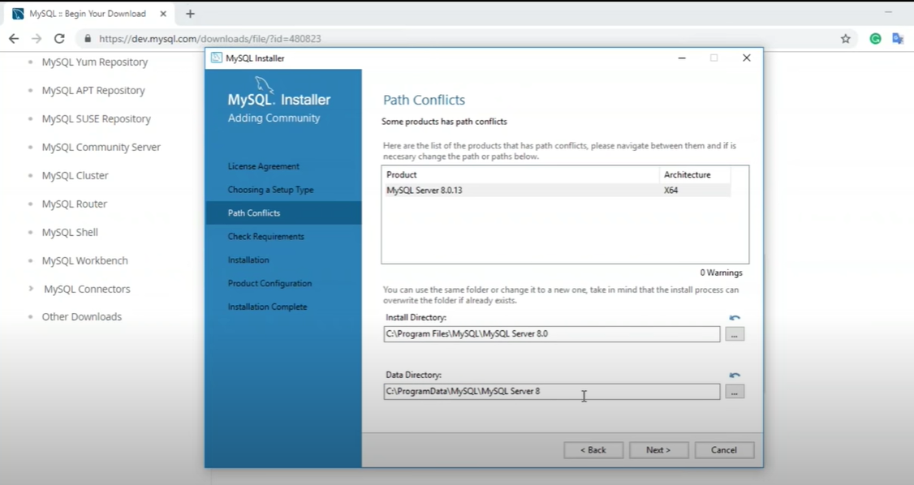

**STEP: - 5**

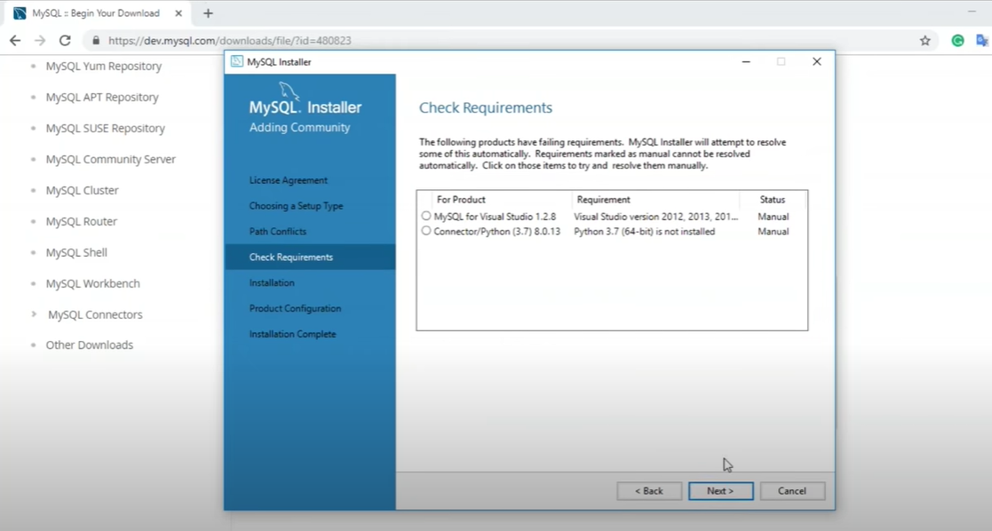

**STEP: - 6**

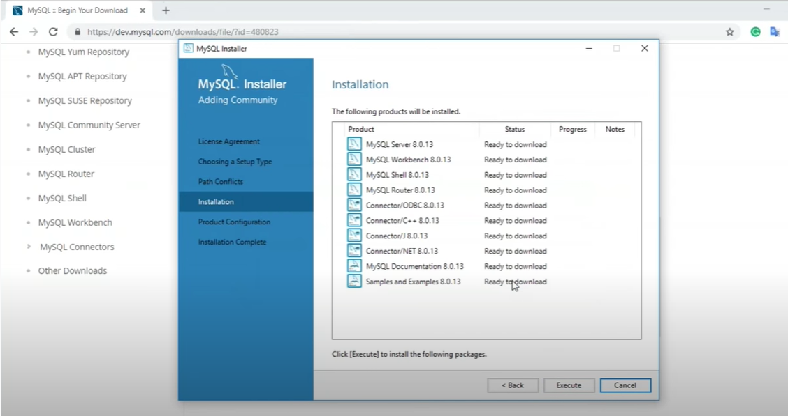

**STEP: - 7**

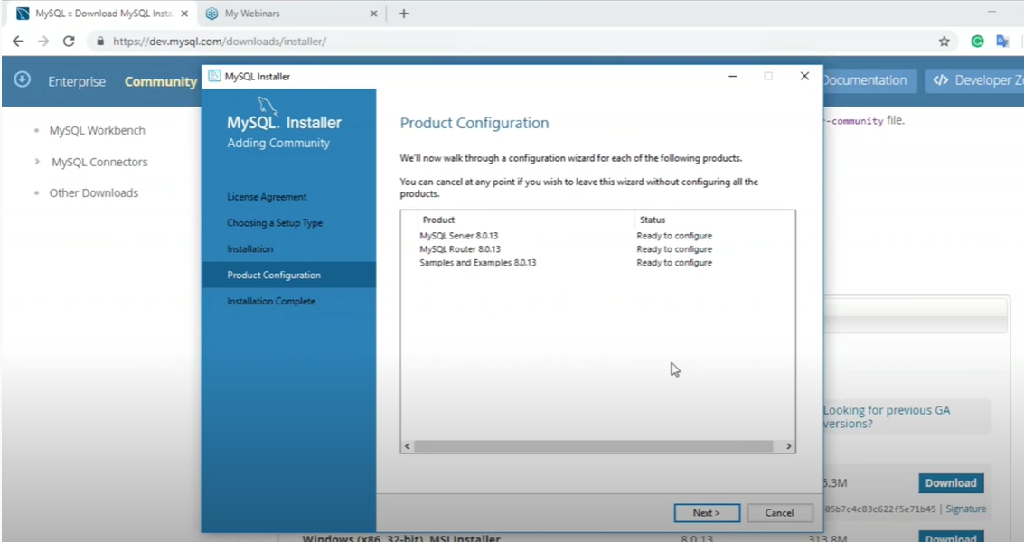

**STEP: - 8**

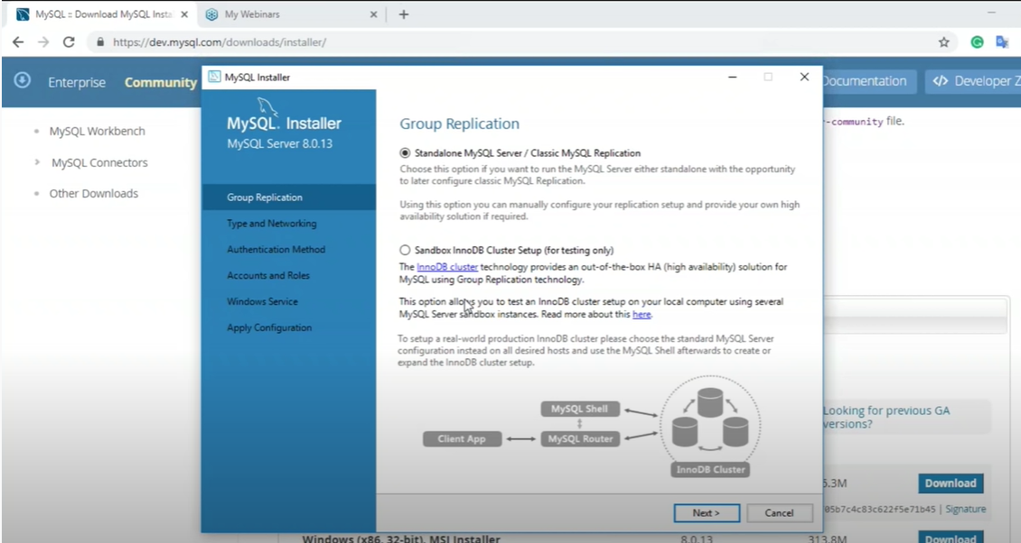

**STEP: - 9**

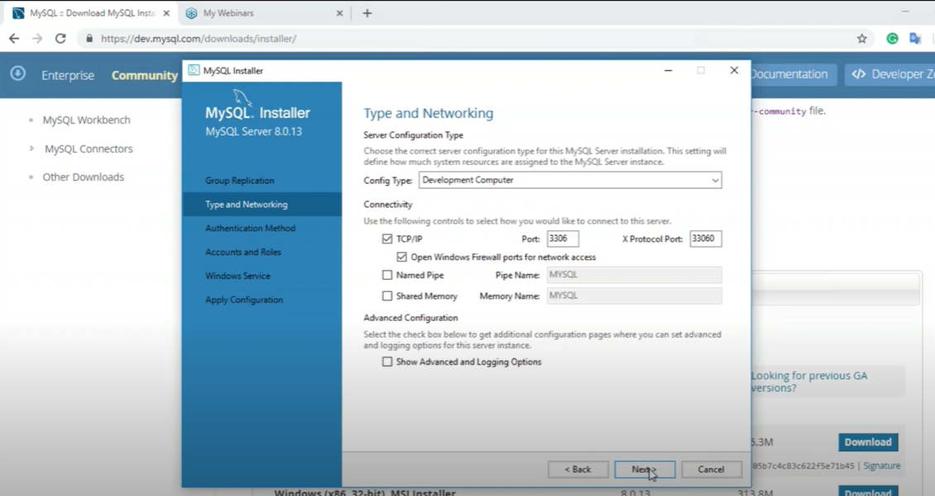

**STEP: - 10**

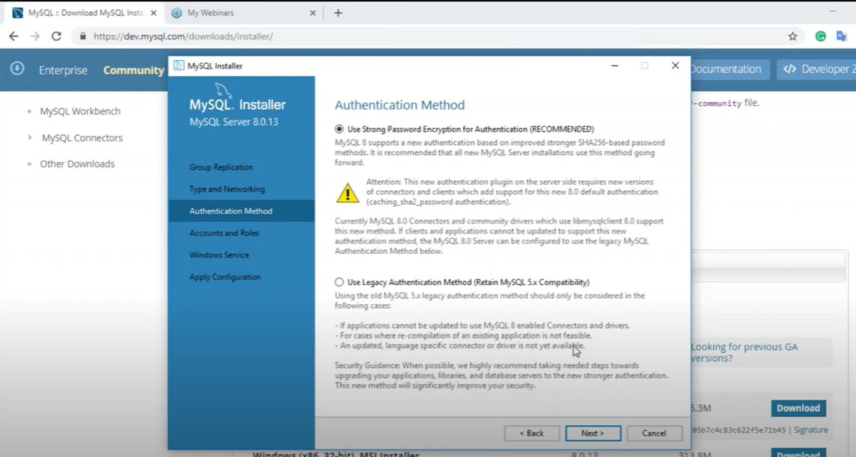

**STEP: - 11**

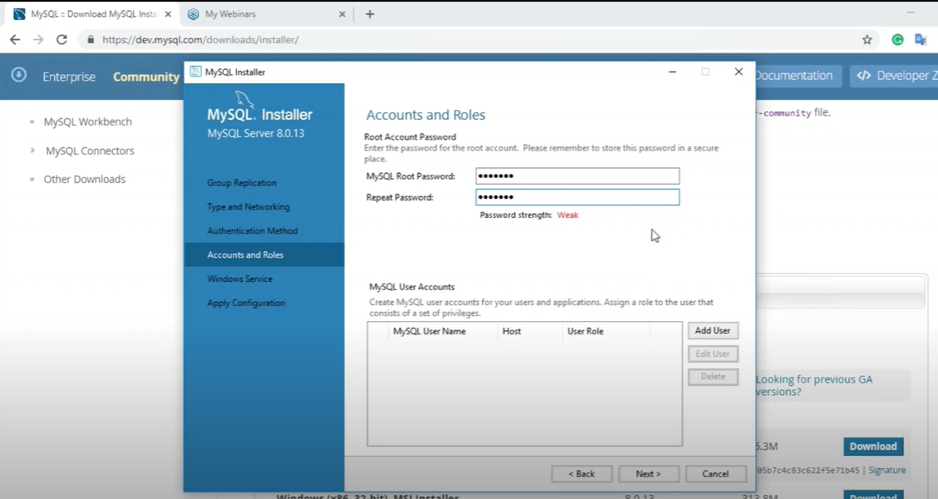

**STEP: - 12**

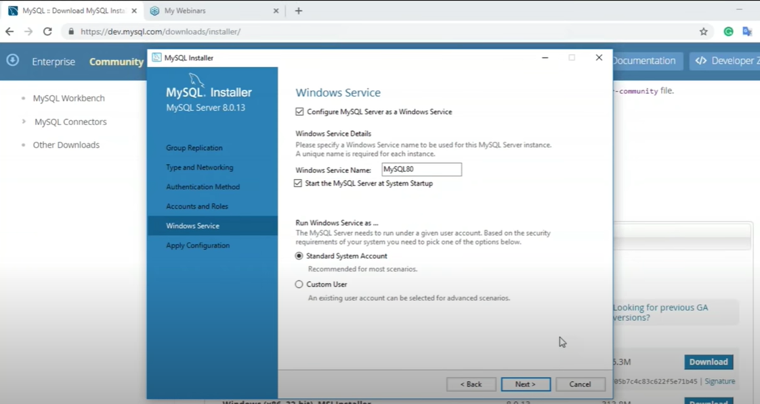

**STEP: - 13**



**STEP: - 14**

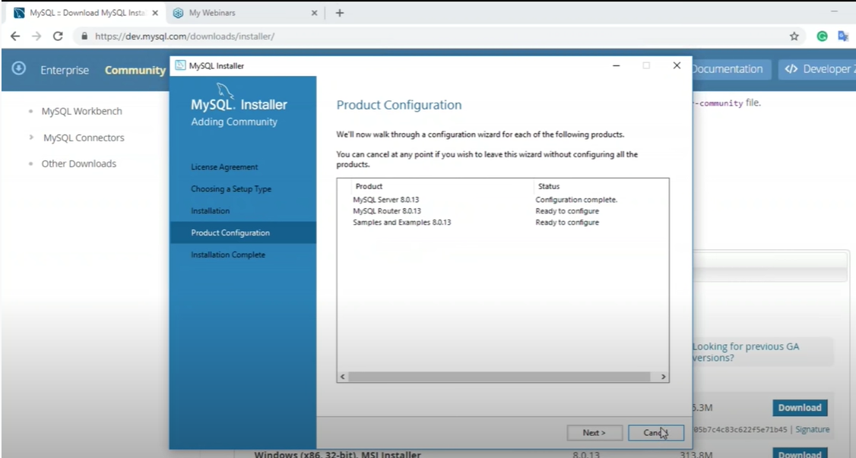

**STEP: - 15**

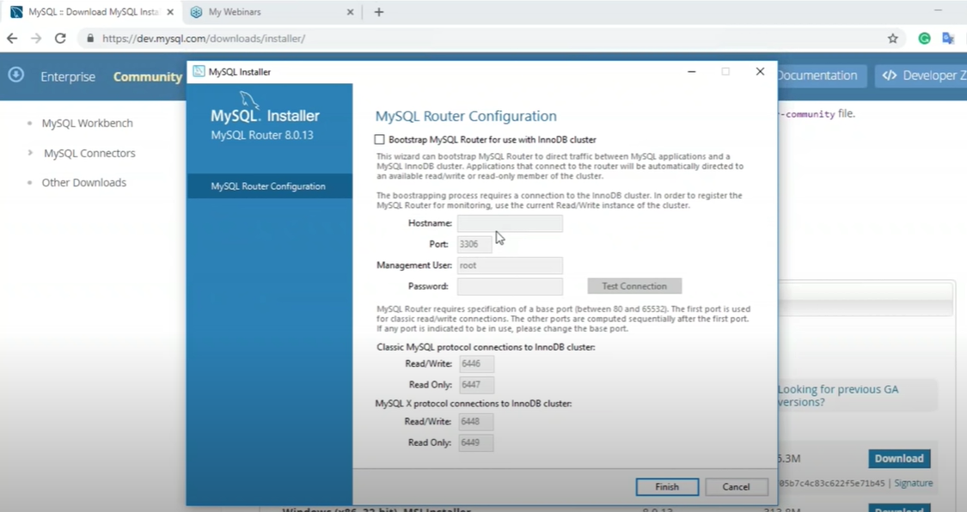

**STEP: - 16**

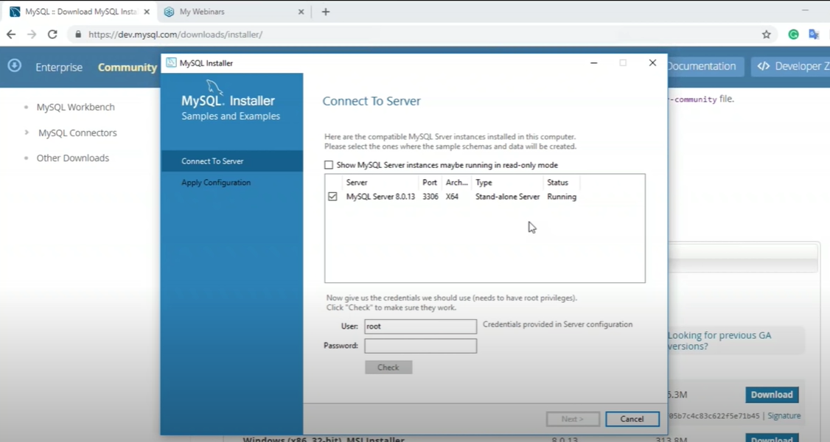

**STEP: - 17**

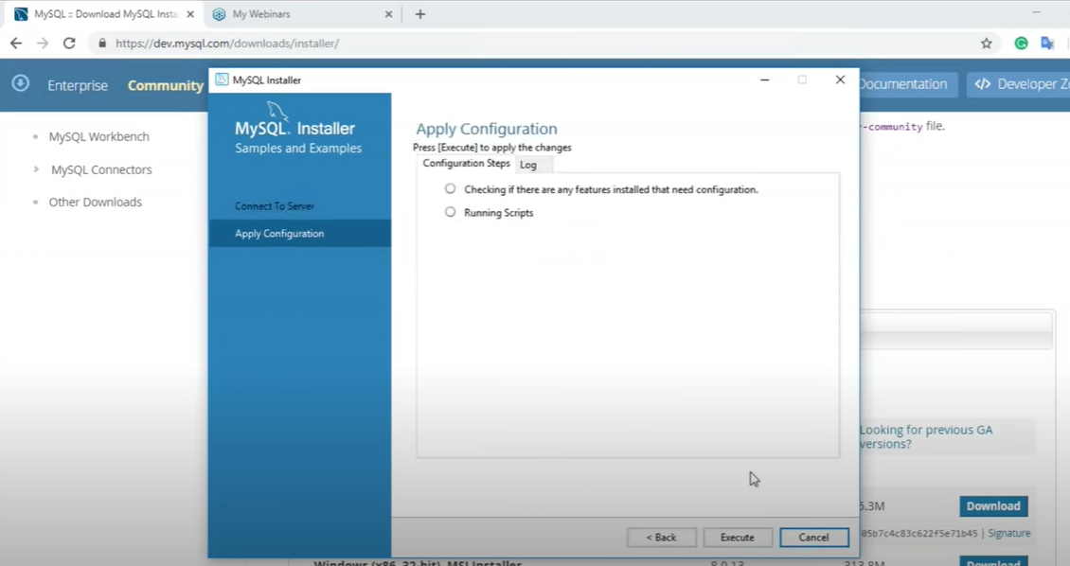

**STEP: - 18**

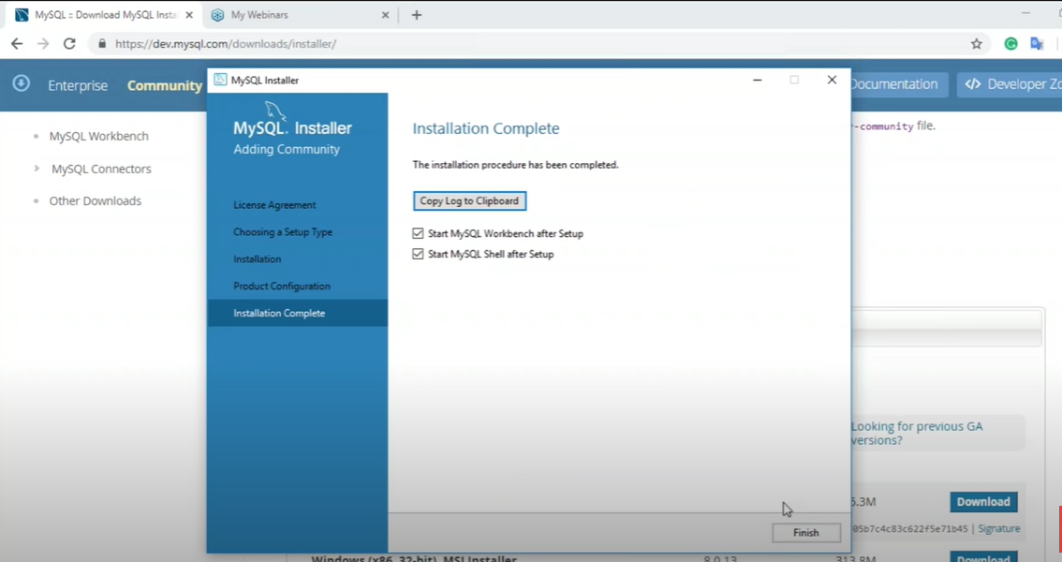

**STEP: - 19**

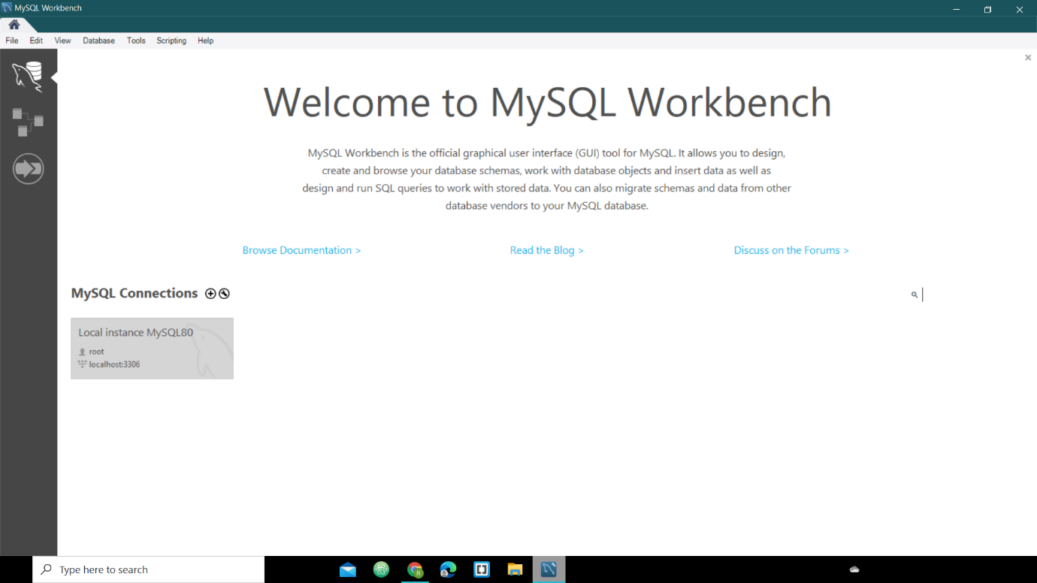

**STEP: - 20**

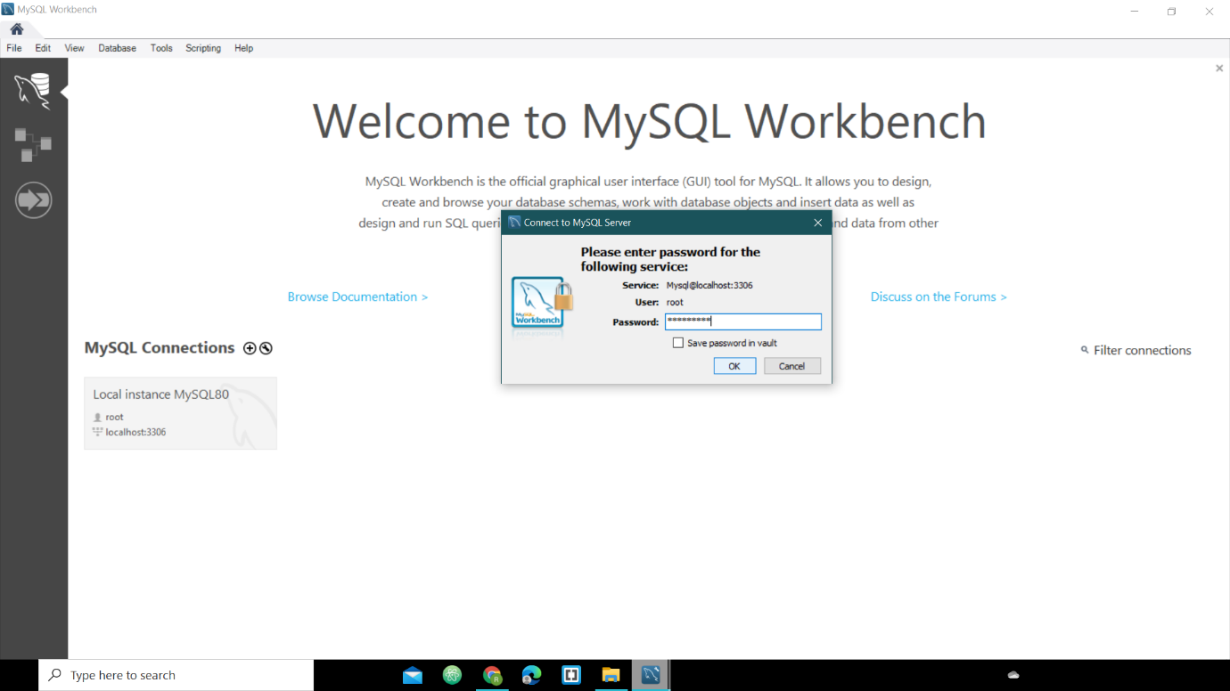

**STEP: - 21**

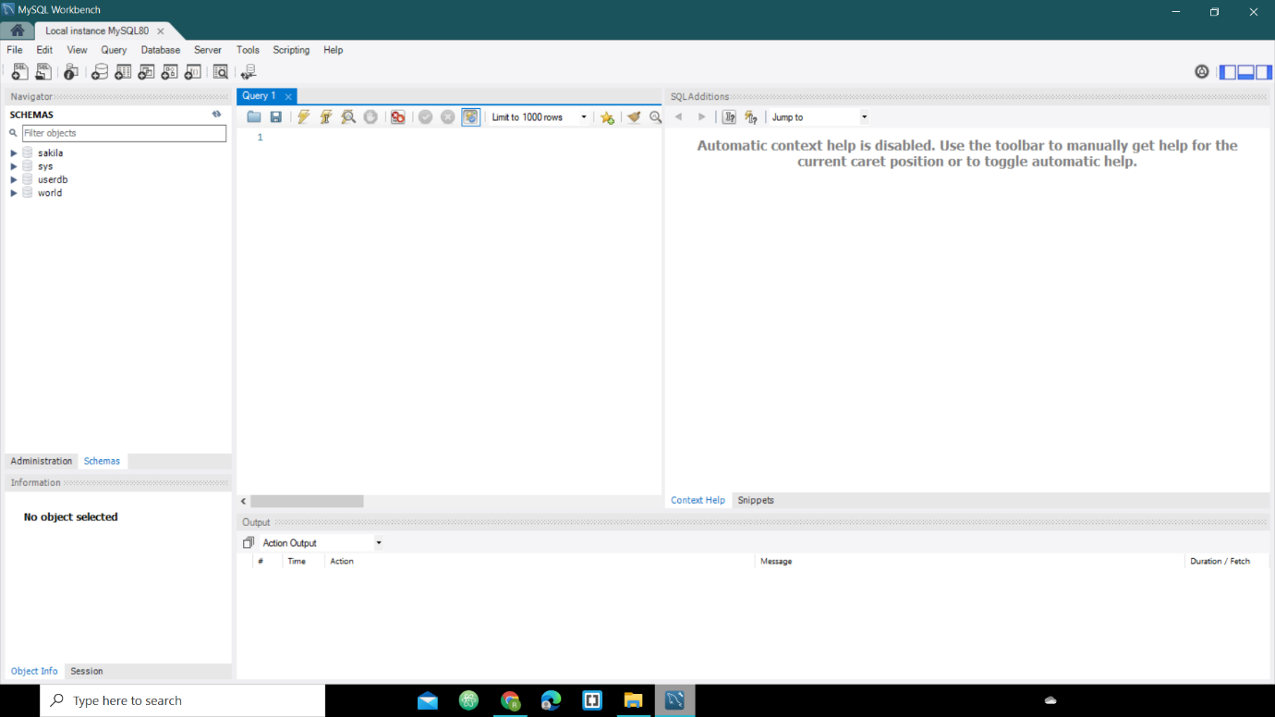

**Assignment – 4**

**19BIT076 (Meet Sheladiya)**

1. **Selection**

Query:

SELECT * FROM card_details WHERE amount>1500

Description:

The above query will select rows from card_details table where amount is greater than 1500

1. **Projection**

Query:

SELECT booking_id, seat_number FROM confirmation

Description:

The above query will select columns booking_id and seat_number from confirmation table

1. **Cartesian Product**

Query:

SELECT payment_method.booking_id, card_details.amount

FROM

payment_method, card_details

Description:

The above query will select columns booking_id and amount from the tables payment_method and card_details respectively and join them.

1. **Union**

Query:

SELECT audience_id, seat_number FROM seat_details

UNION

SELECT audience_id, ROUND (temperature) FROM audience_temperature

Description:

The above query will select columns from respective tables and display unique data and display the common data present in both tables only once.

1. **Set Difference**

Query:

SELECT audience_id, seat_number FROM seat_details

MINUS

SELECT audience_id, ROUND (temperature) FROM audience_temperature

Description:

The above query will select columns from respective tables and display unique data from columns of seat_details table which is not present in columns of audience_temperature table.

1. **Natural Join**

Query:

SELECT * FROM payment_method

NATURAL JOIN

card_details

Description:

The above query will display the common columns from the tables only once.

1. **Composition of any two form (1-6) operators**

Query:

SELECT * FROM payment_method

NATURAL JOIN

card_details

Description:

The above query uses the composition of two operators SELECT and NATURAL JOIN.

1. **Composition of any three form (1-6) operators**

Query:

SELECT * FROM payment_method

NATURAL JOIN

card_details

UNION

confirmation

Description:

The above query uses the composition of three operators SELECT, NATURAL JOIN and UNION. Firstly, the columns of the two tables payment_method and card_details will be Natural Joined and then we will Union them with confirmation table.

**19BIT108(Renish Jagani)**

* **Selection:-**

**Query:-**

SELECT * FROM venue WHERE city_id =21;

**Description**

The above query will select rows from table venue where city_id is 21.

* **Projection:-**

**Query:-**

SELECT match_number, match_id from fixtures;

**Description**

The above query will select columns match_number and match_id from fixtures.

* **Cartesian Product:-**

**Query:-**

SELECT home_team. home_team_ID, away_team. name, away_team. away_team_id

FROM home_team, away_team;

**Description:**  The above query will display all the selected columns from tables home_team, away_team

* **Union**

**Query:-**

SELECT match_number,stadium_id FROM fixtures

UNION

seat_number, stadium_id FROM conformation;

**Description: -** The above query will display only unique data from the selected attributes from respected tables.

* **Set Difference:-**

**Query:-**

SELECT match_number, stadium_id FROM fixtures

MINUS

SELECT seat_number, stadium_id FROM conformation;

**Description: -** The above query will subtract the common data and display the attributes of fixtures which are not present in conformation.

* **Natural Joint:-**

**Query:-**

SELECT * FROM

venue NATURAL JOIN fixtures;

**Description:** The columns with the same name of associated tables will appear once only.

* **Composition of any two from (1-6) operators**

**Query:-**

SELECT * FROM

fixtures NATURAL JOIN conformation

**Description:** The above query uses the composition of two operators SELECT AND NATURAL JOIN.

* **Composition of any three of above from (1-6) operators**

SELECT * FROM

fixtures NATURAL JOIN conformation

UNION

venue

**Description**:The above query uses the composition of three operators SELECT, NATURAL JOIN and union. Firstly, the attributes of two tables fixtures and conformation will be Natural Joined and all the duplicate values of common attribute will be eliminated and then we will union it with venue table.

**19BIT109(Risht Samariya)**

* **Selection:-**

**Query:**

SELECT * FROM food name WHERE MRP=Rs 100

**Description-** Selection will select tuples from table food_and_beverages where the food name mrp is Rs100

* **Projection:-**

**Query:**

SELECT food_id, seat_number from food_and_beverages_order

**Description**- Projection will select the column of food_id and seat_number from table food_and _beverages_order

* **Cartesian Product:-**

**Query:**

SELECT jersy. jersy_id, jersy_order. booking_id FROM jersy, jersy_order

**Description**- It will merge jersy_id and seat_number from jersy table to booking_id from jersy_order table

* **Union:-**

**Query:**

SELECT seat_number from food_and_beverages

UNION

SELECT seat_number from jersy

**Description**- Union will merge the seat_number of table food_and_beverages with seat_number of table jersy which will show only unique data which is not common in both column.

* **Set difference:-**

**Query:**

SELECT booking_id from food_and_beverages_order

MINUS

SELECT booking_id from jersy_order

**Description**- It will subtract the common data from booking_id of both table food_and_beverages_order and jersy_order and it will display it.

* **Natural Join:--**

**Query:-**

SELECT*FROM food_and_beverages NATURAL JOIN jersy

**Description**- The columns of seat_number and MRP in both table will only appear once in the output because it is common in both the table.

* **Composition of any two from (1-6) operators Query:-**

**Query:-**

SELECT booking_id from food_and_beverages

UNION

SELECT booking_id from jersy

**Description**- there is two operation composition projection and union

* **Composition of any three of above from (1-6) operators Query:-**

**Query:-**

SELECT * FROM

food_and_beverages NATURAL JOIN jersy

UNION

Food_and_beverages_order

**Description**- there is three operation composition projection(select), Natural Join and Union

**19BIT141(Rishabh Patel)**

1. **Select Operation**

Query: - SELECT * FROM seat_booking WHERE seat_number >= 45

Description – In Select operation, we are selecting seat_number attribute from seat_booking and having constraint that seat_number must be greater than greater 45.

1. **Projection**

Query: - SELECT username, password FROM login

Description – In above projection operation we select username and password from login table and output both table.

1. **Cartesian Product**

Query: - SELECT login. email_id, login. username, seat_booking. seat_number

FROM login, seat_booking

Description – In Cartesian product is selecting email_id and seat_number from login and seat_number from seat_booking and displaying all three attributes as an output.

1. **Union**

Query: - SELECT email_id, age FROM login

UNION

SELECT email_id, seat_number FROM seat_booking

Description – In Union Operation it includes email_id, age from login and email_id, seat_number from seat_booking and it eliminates duplicate tuples.

1. **Set Difference**

Query: - SELECT email_id, age FROM login

MINUS

SELECT email_id, seat_number FROM seat_booking

Description – The output of set difference (A-B), is removing common values of age and seat_number and display only unique data from the login table.

1. **Natural Join**

Query: - SELECT * FROM login NATURAL JOIN seat_booking

Description – In Natural Join, displaying the attributes only once which are present in both

The tables and uncommon as it is.

1. **Composition of any two from (1-6)operations**

Query: - SELECT login.email_id, login.username, seat_booking.audience_id

FROM login, seat_booking

UNION

SELECT audience_id, gate_number, tier FROM seat_arrangement

Description: - In this above query, there are composition of two operations **Cartesian product** and **Union** operator firstly selecting name, phone_number seat_number attributes from seat_booking table and section from seat_location and cross joining two tables and finally talking union with gate_number which results in displaying all values of respective attributes only once.

1. **Composition of any three from (1-6)operations**

Query: - SELECT email_id, booking_id, audience_id FROM seat_booking

NATURAL JOIN seat_location

UNION

SELECT email_id, phone_number, username FROM login

MINUS

SELECT audience_id FROM seat_arrangement

Description:- In the above query, the Composition of three operators are **Natural Join, Union** and **Set Difference** first we select all attributes from seat_booking and seat_location tables and perform natural join so we get all unique columns and common columns only once then taking union with email_id and phone_number attribute from login input table so we include both attribute in our output then finally set difference with audience_id attribute from seat_arrangement so final output is that we will get all the attributes except of audience_id attribute because we minus it from previous output table.

**19BIT142(Ujash Thakkar)**

1. **Selection Operation**

**QUERY:**

SELECT tuples FORM match_details WHERE match_number =15.

**Description:**

The above query will select rows form table match_details where match_number is 15.

1. **Projection**

**QUERY:**

SELECT seat_number and booking_id FORM audience_verification.

**Description:**

In above query will select seat_number and booking_id from audience_verification.

1. **Cartesian Product**

**QUERY:**

SELECT booking_id, match_number, audience_id FORM audience_verification, tickets_cancelled.

**Description:**

In above query Cartesian product is selecting booking_id, audience_id form audience_verification and match _number from tickets_cancelled.

1. **Union**

**QUERY:**

SELECT stadium_id, audience_id, match_number FORM match_details.

UNION

SELECT stadium_id, stadium_number FORM stadium_details.

**Description:**

In Union Operation in includes stadium_id, audience_id, match_number FORM match_details and stadium_id, stadium_number FORM stadium_details and it eliminates supplicate tuples.

1. **Set Difference**

**QUERY:**

SELECT stadium_id, audience_id, match_number FORM match_details.

MINUS

SELECT stadium_id, stadium_number FORM stadium_details.

**Description:**

The above query will subtract the common data and display the unique data.

1. **Natural Join**

**QUERY:**

SELECT *FROM tickets_cancelled NATURAL JOIN audience_verification.

**Description:**

In above query natural join, print the attrubutes only once which are not present in both tables and uncommon as it is.

1. **Composition of any two from (1-6) operators**

**QUERY:**

SELECT seat_number

FROM audience_verification

NATURAL JOIN tickets_cancelled

**Description:** The above query uses the composition of two operators SELECT AND NATURAL JOIN.

1. **Composition of any three of above from (1-6) operators**

**QUERY:**

SELECT seat_number

FROM audience_verification.

NATURAL JOIN tickets_cancelled

UNION match_detail

**Description:** The above query uses the composition of 3 operators SELECT, UNION AND NATURAL JOIN.

**19BIT144(Ananya Khandelwal)**

1. **Selection** – SELECT * FROM tickets_sold where sold >= 500.

**Description** – Selection will select tuples from table tickets sold where the tickets sold are more than 500.

1. **Projection** – SELECT brand_name, cost from advertisement.

**Description** – Projection will select the column of brand_name and cost from table advertisement.

1. **Cartesian product** - SELECT tickets_sold. stadium_id, tickets_sold. sold, tickets_available. available

FROM tickets_sold, tickets_available.

**Description** – Cartesian product will merge stadium_id, sold and available from tables ticekts_sold and tickets_available respectively.

1. **Union** – Select match_number, sold from tickets sold

UNION

select match_number, available from tickets available.

**Description** – Union will display only unique data from the selected attributes which is not common in both the tables.

1. **Set Difference** - Select match_number, sold from tickets sold

MINUS

select match_number, available from tickets_available.

**Description** – Set difference will subtract the common data and display the attributes of tickets sold which are not present in tickets available.

1. **Natural Join** – SELECT * FROM

tickets_sold

NATURAL JOIN

weather.

**Description** – The columns with same name in both the tables will appear only once in the output.

1. **Composition of Two Operators** – SELECT * FROM

Weather NATURAL JOIN tickets_available

**Description** – This query will composite two individual operators i.e., SELECT & NATURAL JOIN.

1. **Composition of Three Operators** – SELECT * FROM

Weather NATURAL JOIN tickets_available.

UNION

tickets_sold.

**Description** – This query will composite three individual operators i.e., SELECT, NATURAL JOIN, UNION.

**Assignment-5.2**

**19BIT076 (Meet Sheladiya)**

1. **payment_method**

CREATE TABLE `payment_method` (

`booking_id` varchar (255),

`match_id` varchar (255),

`payment_mode` varchar (255),

`payment_id` varchar (255) PRIMARY KEY AUTO_INCREMENT,

`amount` int DEFAULT NULL

);

1. **card_details**

CREATE TABLE `card_details` (

`payment_id` varchar (255) PRIMARY KEY AUTO_INCREMENT,

`card_number` varchar (255),

`amount` int DEFAULT NULL,

`expiry_date` varchar (255)

);

1. **confirmation**

CREATE TABLE `confirmation` (

`booking_id` varchar (255),

`stadium_id` varchar (255),

`match_id` varchar (255),

`seat_number` int DEFAULT NULL PRIMARY KEY AUTO_INCREMENT

);

1. **audience_temperature**

CREATE TABLE `audience_temperature` (

`audience_id` varchar (255) PRIMARY KEY AUTO_INCREMENT,

`temperature` double DEFAULT NULL

)

**19BIT108(Renish Jagani)**

* CREATE TABLE ‘venue(

‘city_id’ int,

‘name’ varchar (255),

‘stadium_id’ varchar (255) PRIMARY KEY AUTO_INCREMENT,

);

* CREATE TABLE ‘fixtures’ (

‘match_number’ int PRIMARY KEY AUTO_INCREMENT,

‘match_id’ varchar (255),

‘stadium_id’ varchar (255),

‘home_team_id’ varchar (255),

‘away_team_id’ varchar (255),

‘city_id’ int,

);

* CREATE TABLE ‘home_team_id’ (

‘home_team_id’ varchar (255) PRIMARY KEY AUTO_INCREMENT,

‘name’ varchar (255),

‘home_stadium’ varchar (255),

);

* CREATE TABLE ‘away_team_id’ (

‘away_team_id’ varchar (255) PRIMARY KEY AUTO_INCREMENT,

‘name’ varchar(255),

)

**19BIT109(Rishit Samariya)**

* CREATE TABLE ‘food_and_beverages’(

‘seat_number’ int PRIMARY KEY AUTO_INCREMENT,

‘food_id’ varchar (255),

‘food_name’ varchar (255),

‘MRP’ int,

);

* CREATE TABLE ‘food_and_beverages_order’(

‘seat_number’ int PRIMARY KEY AUTO_INCREMENT,

‘food_id’ varchar (255),

‘booking_id’ varchar (255),

);

* CREATE TABLE ‘jersy’(

‘seat_number’ int PRIMARY KEY AUTO_INCREMENT

‘jersy_id’ varchar (255),

‘team_name’ varchar (255),

‘size’ int,

‘MRP’ int,

);

* CREATE TABLE ‘jersy_order’(

‘seat_number’ int PRIMARY KEY AUTO_INCREMENT

‘jersy_id’ varchar (255),

‘booking_id’ varchar (255),

);

**19BIT141(Rishabh Patel)**

* **Login:-**

CREATE TABLE `stadium_seat_booking_database`. `login` (

`email_id` VARCHAR (45) NOT NULL,

`username` VARCHAR (245) NOT NULL,

`password` VARCHAR (245) NOT NULL,

`f_name` VARCHAR (245) NOT NULL,

`l_name` VARCHAR (245) NOT NULL,

`gender` VARCHAR (245) NOT NULL,

`age` INT NOT NULL,

`phone_number` INT (10) NOT NULL,

`security_question` VARCHAR (245) NOT NULL,

`answer` VARCHAR (245) NOT NULL,

PRIMARY KEY (`email_id`, `username`, `password`));

* **Seat_booking:-**

CREATE TABLE `stadium_seat_booking_database`.`seat_booking` (

`booking_id` VARCHAR (245) NOT NULL,

`email_id` VARCHAR (245) NOT NULL,

`name` VARCHAR (245) NOT NULL,

`phone_number` INT (10) NOT NULL,

`address` VARCHAR (245) NOT NULL,

`postal_code` INT (10) NOT NULL,

`seat_number` INT (10) NOT NULL,

`audience_id` VARCHAR (245) NOT NULL,

`match_id` VARCHAR (245) NOT NULL,

PRIMARY KEY (`booking_id`, `phone_number`, `seat_number`, `audience_id`, `match_id`));

* **Seat arrangement:-**

CREATE TABLE `stadium_seat_booking_database`.`seat_arrangement` (

`audience_id` VARCHAR (245) NOT NULL,

`gate_number` INT (10) NOT NULL,

`tier` INT (10) NOT NULL,

`stadium_id` VARCHAR (245) NOT NULL,

PRIMARY KEY (`audience_id`));

* **Seat Location:-**

CREATE TABLE `stadium_seat_booking_database`.`seat_location` (

`seat_number` INT (10) NOT NULL,

`section` VARCHAR (245) NOT NULL,

PRIMARY KEY (`seat_number`));

* **Seat Details:-**

CREATE TABLE `stadium_seat_booking_database`.`seat_details` (

`booking_id` VARCHAR (245) NOT NULL,

`audience_id` VARCHAR (245) NOT NULL,

`match_id` VARCHAR (245) NOT NULL,

`seat_number` INT (10) NOT NULL,

`seat_category` VARCHAR (245) NOT NULL,

`price` DOUBLE (10) NOT NULL,

PRIMARY KEY (`booking_id`, `audience_id`, `seat_number`));

**19BIT142(Ujash Thakkar)**

1. audience_verification

CREATE TABLE’ audience_verification` (

‘booking_id’ varchar (255),

‘audience_id’ varchar (255), PRIMARY KEY AUTO_INCREMENT

‘phone_number’ int (10),

‘seat_number’ int (10), PRIMARY KEY AUTO_INCREMENT

‘aadhar_number’ int (12),

PRIMARY KEY (`booking_id’, ‘phone_number’, ‘aadhar_number’));

1. ticket_cancelled

CREATE TABLE` ticket_cancelled ‘(

‘stadium_id` varchar (255),

‘match_id` varchar (255),

‘match_number’ int DEFAULT NULL, PRIMARY KEY AUTO_INCREMENT

‘audience_id’ varchar (255), PRIMARY KEY AUTO_INCREMENT

1. stadium_details

CREATE TABLE ‘stadium_details’ (

‘stadium_id’ varchar (255), PRIMARY KEY AUTO_INCREMENT

‘stadium_name’ varchar (255),

‘address’ varchar (255),

‘capacity’ int,

1. match_details

CREATE TABLE ‘match_details’ (

‘stadium_id’ varchar (255),

‘audience_id’ varchar (255), PRIMARY KEY AUTO_INCREMENT

‘match_number’ INT DEFAULT NULL, PRIMARY KEY AUTO_INCREMENT

‘match_id` varchar (255),

‘date_of_match’ varchar (255),

‘match_timing’ varchar (255),

**19BIT144(Ananya Khandelwal)**

1. CREATE TABLE `tickets_sold` (

`Stadium_id` varchar (255),

`Match_id` varchar (255),

`Match_number` int DEFAULT NULL, PRIMARY KEY AUTO_INCREMENT

`Sold` int DEFAULT NULL

);

1. CREATE TABLE `advertisement` (

`Audience_id` varchar (255), PRIMARY KEY AUTO_INCREMENT

`Brand_name` varchar (255),

`Cost (In Rs) ` double DEFAULT NULL

);

1. TABLE `weather` (

`Match_Number` int DEFAULT NULL, PRIMARY KEY AUTO_INCREMENT

`Temperature (Celsius) ` double DEFAULT NULL,

`Humidity (%) ` int DEFAULT NULL

;

1. CREATE TABLE `tickets_available` (

`Stadium_id` varchar (255),

`Match_id` varchar (255),

`Match_number` int DEFAULT NULL, PRIMARY KEY AUTO_INCREMENT

`Available` int DEFAULT NULL

)

**Assignment – 5.3**

**19BIT076 (Meet Sheladiya)**

1. **Aggregate functions**

**Max**

Query:

SELECT MAX (temperature) FROM audience_temperature

1. **Numeric**

Query:

SELECT ROUND (temperature) FROM audience_temperature

1. **Date**

Query:

SELECT * FROM card_details WHERE expiry_date=’2023-05-27’

1. **String function**

Query:

SELECT LENGTH (payment_mode) FROM payment_method

**19BIT108 (Renish Jagani)**

* **Aggregate function:-**

SELECT COUNT (city_id) FROM venue;

* **Built-in Numeric Function:-**

SELECT MAX (humidity) FROM weather;

* **String Functions:-**

SELECT name, ASCII (name)

FROM home_team;

* **Date Function:-**

SELECT YEAR ('2017/08/25');

**19BIT109 (Rishit Samariya)**

* **Aggregate function-**

**Query:-**

SELECT MAX (MRP) FROM food_and_beverages;

* **Built-in Numeric Function-**

**Query:-**

SELECT ABS (Size) FROM Jersy;

* **String Function-**

**Query:-**

Select food_name, UPPER (food_name) from food_and_beverages

* **Date Function-**

**Query:-**

SELECT * FROM card_details WHERE expiry_date=’2025-01-02’

**19BIT141 (Rishabh Patel)**

1. **Aggregate function:-**

SELECT SUM (age) FROM login;

1. **Built-in Numeric Function:-**

SELECT ROUND (price) FROM seat_details;

1. **String Function:-**

SELECT CONCAT (f_name, l_name) FROM login;

1. **Date Function:-**

SELECT * FROM card_details WHERE expiry_date = ‘2023-24-11’

**19BIT142(Ujash Thakkar)**

1. **Aggregate function**

**Query:**

SELECT COUNT (audience_id) FROM ticket_cancelled

1. **Numeric function**

**Query:**

SELECT ABS (seat_number) FROM audience_verification

1. **Date function**

**Query:**

SELECT date_of_match FROM match_details WHERE

date_of_match=’2021-04-03’;

1. **String function**

**Query:**

SELECT stadium_name, LOWER (stadium_name) FROM stadium_details

**19BIT144 (Ananya Khandelwal)**

1. **Aggregate Function:-**

SELECT avg (cost) FROM advertisement.

1. **Built in Numeric function:-**

SELECT ROUND (temperature) FROM weather where match number = 2.

1. **Date:-**

SELECT YEAR (‘2019/0510’)

1. **String:-**

SELECT length (brand_name) FROM advertisement where audience id = _________.

**Assignment-5.4**

**19BIT076 (Meet Sheladiya)**

1. **Set Operations**
2. **Union**

Query:

SELECT audience_id, seat_number FROM seat_details

UNION

SELECT audience_id, ROUND (temperature) FROM audience_temperature

1. **Union All**

Query:

SELECT audience_id, seat_number FROM seat_details

UNION ALL

SELECT audience_id, ROUND (temperature) FROM audience_temperature

1. **Intersect**

Query:

SELECT audience_id, seat_number FROM seat_details

INTERSECT

SELECT audience_id, ROUND (temperature) FROM audience_temperature

1. **Minus**

Query:

SELECT audience_id, seat_number FROM seat_details

MINUS

SELECT audience_id, ROUND (temperature) FROM audience_temperature

1. **Sub-queries**

Query:

SELECT * FROM audience_temperature WHERE temperature>37

1. **Correlated sub-queries**

Query:

SELECT booking_id, match_id, amount

FROM payment_method

WHERE payment_id = (SELECT payment_id FROM card_details WHERE amount>4900)

**19BIT108 (Renish Jagani)**

* **Set operations:-**

SELECT match_number, stadium_id FROM fixtures

UNION

seat_number, stadium_id FROM conformation;

* **Sub queries:-**

SELECT *

FROM fixtures

WHERE match_id IN (SELECT match_id

FROM fixtures

WHERE city_id > 20);

* **Co-related Sub queries:-**

SELECT match_id from fixtures where stadium_id= (SELECT STADIUM_ID FROM VENUE WHERE city_id>6)

**19BIT109 (Rishit Samariya)**

1. **Set Operations:-**

* **Union-**

**Query:-**

SELECT seat_number from food_and_beverages

UNION

SELECT seat_number from jersy

* **Union All-**

**Query:-**

SELECT seat_number from food_and_beverages

UNION All

SELECT seat_number from jersy

* **Intersect-**

**Query:-**

SELECT seat_number from food_and_beverages

INTERSECT

SELECT seat_number from jersy

* **Minus-**

**Query:-**

SELECT booking_id from food_and_beverages_order

MINUS

SELECT booking_id from jersy_order

1. **Sub-queries:-**

**Query:-**

SELECT * FROM food name WHERE MRP=Rs 100

1. **Correlated sub-queries:-**

**Query:-**

SELECT food_name, seat_number,

FROM food_and_beverages

WHERE food_id = (SELECT food_id FROM food_and_beverages_order WHERE seat_number = 10)

**19BIT141 (Rishabh Patel)**

1. **Set Operations:-**

* **INTERSECT:-**

**Query:-**

SELECT email_id, username, password FROM login

INTERSECT

SELECT email_id, name, phone_number FROM seat_booking;

* **UNION:-**

**Query:-**

SELECT email_id, age FROM login

UNION

SELECT email_id, seat_number FROM seat_booking;

* **UNION ALL:-**

**Query:-**

SELECT * FROM seat_booking

UNION ALL

SELECT * FROM seat_arrangement;

* **MINUS:-**

**Query:-**

SELECT audience_id, name, seat_number FROM seat_booking

MINUS

SELECT audience_id, gate_number, tier;

1. **Sub-Queries:-**

* **UPDATE:-**

**Query:-**

UPDATE seat_details

SET price = price * 0.5

WHERE 4 >= (SELECT COUNT (match_id) FROM seat_booking

WHERE seat_booking.seat_number = seat_details.seat_number)

1. **Correlated Sub-Queries:-**

**Query:-**

SELECT name, email_id, seat_number

FROM seat_booking

WHERE booking_id = (SELECT booking_id FROM seat_details

WHERE audience_id = ‘A-011’);

**19BIT142(Ujash Thakkar)**

1. **Set Operations**

**Union**

**QUERY:**

SELECT stadium_id, audience_id, match_number FORM match_details.

UNION

SELECT stadium_id, stadium_number FORM stadium_details.

1. **Sub-queries**

**QUERY:** SELECT * FROM audience_temperature WHERE temperature>37

1. **Correlated sub-queries**

**QUERY:**

SELECT stadium_id, stadium_name, FROM stadium_details

WHERE match_id = (SELECT match_id FROM match_details

WHERE match_number>23)

**19BIT144 (Ananya Khandelwal)**

1. **Set Operations:-**

SELECT * FROM weather

INTERSECT

SELECT * FROM tickets_available.

1. **Sub Queries:-**

SELECT * FROM advertisement WHERE audience_id IN (SELECT audience_id FROM advertisement WHERE cost > 100000)

1. **Correlated Sub Queries:-**

SELECT stadium_id, match_id FROM tickets_available

WHERE match_number= (SELECT match_number FROM tickets_sold WHERE sold>4900)

**Assignment-5.5**

**19BIT076 (Meet Sheladiya)**

1. **Group By;-**

Query:-

SELECT payment_mode, SUM(amount) FROM payment_method

GROUP BY payment_mode

1. **Having;-**

Query:-

SELECT stadium_id, COUNT(booking_id) FROM confirmation

GROUP BY stadium_id

HAVING COUNT(booking_id)>1

1. **Order By;-**

Query:-

SELECT * FROM card_details

ORDER BY amount

**19BIT108 (Renish Jagani)**

* **Group By:-**

SELECT COUNT (stadium_id), name  
FROM venue  
GROUP BY name;

* **Having:-**

SELECT COUNT (stadium_id), name  
FROM venue  
GROUP BY name

HAVING COUNT (stadium_id)> 1

(RETURNS ONLY CITY THAT HAS MORE THAN ONE STADIUM)

* **Order By:-**

SELECT * FROM fixtures ORDER BY city_id;

**19BIT109 (Rishit Samariya)**

* **Group By-**

**Query:-**

SELECT food_name, AVG (MRP) FROM food_and_beverages

GROUP BY food_name;

* **ORDER BY-**

**Query:-**

SELECT * FROM food_and_beverages ORDER BY MRP DESC;

* **HAVING-**

**Query:-**

SELECT COUNT (MRP), food_name FROM food_and_beverages

GROUP BY food_name

HAVING COUNT (MRP)>=50;

**19BIT141 (Rishabh Patel)**

1. **Group By:-**

**Query:-**

SELECT security_question, COUNT (email_id) FROM login

GROUP BY security_question;

1. **Having:-**

**Query:-**

SELECT COUNT (email_id), age FROM login

GROUP BY age

HAVING COUNT (email_id) >= 8;

1. **ORDER BY:-**

**Query:-**

SELECT COUNT (name), address FROM seat_booking

GROUP BY address

ORDER BY COUNT (name) DESC;

**19BIT142(Ujash Thakkar)**

1. **Group By**

Query:

SELECT stadium_name, stadium_id

FROM stadium_details

GROUP BY stadium_name;

1. **Having**

Query:

SELECT stadium_name, stadium_id

FROM stadium_details

GROUP BY stadium_name

HAVING COUNT (*) < 8;

1. **Order By**

Query:

SELECT *

FROM match_details

ORDER BY date_of_match;

**19BIT144 (Ananya Khandelwal)**

1. **Group by:-**

SELECT humidity, count (match_number) FROM weather

GROUP BY humidity.

1. **Having:-**

SELECT stadium_id, match_id, match_number FROM tickets_available

GROUP BY available

HAVING available>500.

1. **Order by:-**

SELECT * FROM weather

ORDER by temperature

**Assignment – 5.6**

**19BIT076 (Meet Sheladiya)**

1. **Join**
2. **Inner Join**

Query:-

SELECT card_details.amount, payment_method.booking_id, payment_method.match_id FROM payment_method

INNER JOIN card_details

ON payment_method. payment_id=card_details.payment_id

1. **Left Join**

Query:-

SELECT card_details.amount, payment_method.booking_id, payment_method.match_id FROM payment_method

LEFT JOIN card_details

ON payment_method.payment_id=card_details.payment_id

1. **Right Join**

Query:-

SELECT card_details.amount, payment_method.booking_id, payment_method.match_id FROM payment_method

RIGHT JOIN card_details

ON payment_method.payment_id=card_details.payment_id

1. **Full Join**

Query:-

SELECT card_details.amount, payment_method.booking_id, payment_method.match_id FROM payment_method

FULL JOIN card_details

ON payment_method.payment_id=card_details.payment_id

1. **Exists**

Query:-

SELECT booking_id, match_id

FROM payment_method

WHERE EXISTS (SELECT * FROM card_details WHERE payment_method.payment_id=card_details.payment_id AND amount>2500)

1. **Any**

Query:-

SELECT booking_id

FROM payment_method

WHERE payment_id = ANY (SELECT payment_id FROM card_details WHERE amount<2000)

1. **All**

Query:-

SELECT booking_id

FROM payment_method

WHERE payment_id = ALL (SELECT payment_id FROM card_details WHERE amount>1000)

**19BIT108 (Renish Jagani)**

* **Join operations inner join:-**

SELECT fixtures.match_number, fixtures.match_id,home_team.name

from fixtures

INNER JOIN home_team

ON home_team.home_team_id = fixtures.home_team_id

* **Left join:-**

SELECT fixtures. match number, fixtures.match_id,home_team.name

from fixtures

LEFT JOIN home_team

ON home_team.home_team_id = fixtures.home_team_id

* **Right join:-**

SELECT fixtures.match_number, fixtures.match_id,home_team.name

from fixtures

RIGHT JOIN home_team

ON home_team.home_team_id = fixtures.home_team_id

* **Full join:-**

SELECT fixtures.match_number, fixtures.match_id,home_team.name

from fixtures

FULL JOIN home_team

ON home_team.home_team_id = fixtures.home_team_id

* **Exist:-**

SELECT match_id, match_number from fixtures

WHERE EXISITS (SELECT * FROM away_team WHERE away_team.away_team_id = fixtures.home_team_id)

* **All:-**

SELECT match_id from fixtures where stadium_id= All (SELECT STADIUM_ID FROM VENUE WHERE CITY_ID>6)

* **Any:-**

SELECT match_id from fixtures where stadium_id= Any (SELECT STADIUM_ID FROM VENUE WHERE CITY_ID>6)

**19BIT109 (Rishit Samariya)**

* **INNER JOIN-**

**Query:-**

SELECT Food_and_beverages_order.booking_id, Food_and_beverages.MRP, Food_and_beverages_order.booking_id

FROM food_and_bevearges

INNER JOIN Food_and_beverages_order.

ON food_and_beverages.seat_number = food_and_beverages_order.seat_number;

* **Left Join-**

**Query:-**

SELECT jersy_order.booking_id, jersy.team_name

FROM jersy_order

LEFT JOIN jersy

ON jersy.seat_number =jersy_order.seat_number;

* **Right Join-**

**Query:-**

SELECT Food_and_beverages_order.booking_id, Food_and_beverages.booking_id

FROM food_and_bevearges

RIGHT JOIN Food_and_beverages_order.

ON food_and_beverages.seat_number = food_and_beverages_order.seat_number;

* **FULL JOIN-**

**Query:-**

SELECT Food_and_beverages_order.booking_id, Food_and_beverages.booking_id

FROM food_and_bevearges

FULL JOIN Food_and_beverages_order.

ON food_and_beverages.seat_number = food_and_beverages_order.seat_number;

* **EXISTS-**

**Query:-**

SELECT food_id from food_and_beverages_order

WHERE EXISTS (SELECT * FROM jersy_order

WHERE food_and_beverages_order.seat_number = jersy_order.seat_number)

* **All-**

**Query:-**

SELECT food_name

FROM food_and_beverages

WHERE food_id = ALL (SELECT food_id FROM food_and_beverages_order WHERE seat_number = 10)

* **ANY-**

**Query:-**

SELECT food_name

FROM food_and_beverages

WHERE food_id = ANY (SELECT food_id FROM food_and_beverages_order WHERE seat_number = 10)

**19BIT141 (Rishabh Patel)**

* **Join Operations:-**

1. **INNER JOIN:-**

**Query:-**

SELECT seat_arrangement. gate_number, seat_details. match_id, seat_details. seat_number FROM seat_details

INNER JOIN seat_arrangement

ON seat_details. audience_id = seat_arrangement. audience_id;

1. **LEFT JOIN:-**

**Query:-**

SELECT seat_arrangement. gate_number, seat_details. match_id, seat_details. seat_number FROM seat_details

LEFT JOIN seat_arrangement

ON seat_details. audience_id = seat_arrangement. audience_id;

1. **RIGHT JOIN:-**

**Query:-**

SELECT seat_arrangement. gate_number, seat_details. match_id, seat_details. seat_number FROM seat_details

RIGHT JOIN seat_arrangement

ON seat_details. audience_id = seat_arrangement. audience_id;

1. **FULL JOIN:-**

**Query:-**

SELECT seat_arrangement. gate_number, seat_details. match_id, seat_details. seat_number FROM seat_details

FULL JOIN seat_arrangement

ON seat_details. audience_id = seat_arrangement. audience_id;

* **Exists:-**

**Query:-**

SELECT f_name, l_name FROM login

WHERE EXISTS (SELECT * FROM seat_booking

WHERE login. email_id = seat_booking. Email_id AND age>=25)

* **Any:-**

**Query:-**

SELECT name

FROM seat_booking

WHERE audience_id = ANY (SELECT audience_id FROM seat_arrangement

WHERE gate_number = 2 OR gate_number = 4)

* **ALL:-**

**Query:-**

SELECT name

FROM seat_booking

WHERE audience_id = ALL (SELECT audience_id FROM seat_arrangement

WHERE gate_number = 2 OR gate_number = 4);

**19BIT142(Ujash Thakkar)**

1. **Inner Join**

**Query:**

**SELECT** audience_verification. phone number, match_details. match_number, match_details. match_timing FROM match_details

**INNER JOIN** audience_verification

**ON** match_details. audience_id = audience_verification. audience_id;

1. **Left Join**

**Query:**

**SELECT** audience_verification. phone number, match_details. match_number, match_details. match_timing FROM match_details

**LEFT JOIN** audience_verification

**ON** match_details. audience_id = audience_verification. audience_id;

1. **Right join**

**Query:**

**SELECT** audience_verification. phone number, match_details. match_number, match_details. match_timing FROM match_details

**RIGHT JOIN** audience_verification

**ON** match_details. audience_id = audience_verification. audience_id;

1. **Full join**

**Query:**

**SELECT** audience_verification. phone number, match_details. match_number, match_details. match_timing FROM match_details

**FULL JOIN** audience_verification

**ON** match_details. audience_id = audience_verification. audience_id;

1. **Exists**

**Query:**

**SELECT** booking_id, seat_number

FROM audience_verification

WHERE **EXISTS** (SELECT * FROM match_details WHERE

audience_verification.audience_id=match_details.audience_id)

1. **Any**

**Query:**

**SELECT** booking_id

FROM audience_verification

WHERE audience_id = (SELECT audience_id FROM ticket_cancelled WHERE seat_number is=564)

1. **All**

**Query:**

**SELECT** booking_id

FROM audience_verification

WHERE audience_id = (SELECT audience_id FROM ticket_cancelled WHERE seat_number is=465)

**19BIT144 (Ananya Khandelwal)**

1. **INNER JOIN**

Query -

SELECT weather.temperature, tickets_available.stadium_id, tickets_available.match_id FROM tickets_available

INNER JOIN weather

ON tickets_available.match_number = weather.match_number

1. **LEFT JOIN**

Query

SELECT weather.temperature, tickets_available.stadium_id, tickets_available.match_id FROM tickets_available

LEFT JOIN weather

ON tickets_available.match_number = weather.match_number

1. **RIGHT JOIN**

Query

SELECT weather.temperature, tickets_available.stadium_id, tickets_available.match_id FROM tickets_available

RIGHT JOIN weather

ON tickets_available.match_number = weather.match_number

1. **FULL JOIN**

Query

SELECT weather.temperature, tickets_available.stadium_id, tickets_available.match_id FROM tickets_available

FULL JOIN weather

ON tickets_available.match_number = weather.match_number

1. **EXIST**

SELECT temperature, humidity FROM weather

WHERE EXISTS (SELECT * FROM tickets_available WHERE weather.match_number=tickets_available.match_number

1. **ALL**

SELECT brand_name FROM advertisement

WHERE match_number=ALL (SELECT match_number FROM tickets_sold WHERE available>500)

1. **ANY**

SELECT sold FROM tickets_sold

WHERE match_number=ANY (SELECT match_number FROM tickets_available WHERE available>4900)

**Assignment – 5.7**

Study and implement the assignment topic from the Embedded SQL, PL SQL Concepts, Cursors, Stored Procedures, Stored Function, Triggers, Tuple relational calculus, domain relational calculus.

**Objective: - To Learn and implement advanced concepts of Embedded SQL**

**EXEC SQL** connect to **server** user **user_name** using **password**;

// initially Connecting the database to the host language and required username and password to login

**Query – 1:-**

EXEC SQL BEGIN DECLARE SECTION;

Int age;

EXEC END DECLARE SECTION;

EXEC SQL

declare c cursor for

SELECT email_id, first_name FROM LOGIN

WHERE 50>: age;

EXEC SQL open c;

EXEC SQL fetch c into :se, :sn;

EXEC SQL close c;

**Query – 2:-**

EXEC SQL

declare c cursor for select match_id, match_number FROM fixtures

where city_id>:5;

EXEC SQL open c;

EXEC SQL fetch c into :si, :sn;

EXEC SQL close c;

**Query – 3:-**

EXEC SQL

declare a cursor for select stadium_id, available FROM tickets_available

WHERE available>:750;

EXEC SQL open a;

EXEC SQL fetch into :si, :si;

EXEC SQL close a;

**Query – 4:-**

EXEC SQL

declare d cursor for select payment_id, card_number FROM card_details

WHERE amount>:500;

EXEC SQL open d;

EXEC SQL fetch d into :si, :si;

EXEC SQL close d;

**Query – 5:-**

EXEC SQL

declare e cursor for select food_id, seat_number FROM food_and_beverages

where MRP>:100;

EXEC SQL open e;

EXEC SQL fetch e into :si, :si;

EXEC SQL close e;

**Query:-6:-**

EXEC SQL

Declare j cursor for stadium_id, stadium_name, FROM stadium_details

WHERE capacity>:450;

EXEC SQL open j;

EXEC SQL fetch j into :si, :sn;

EXEC SQL close j;